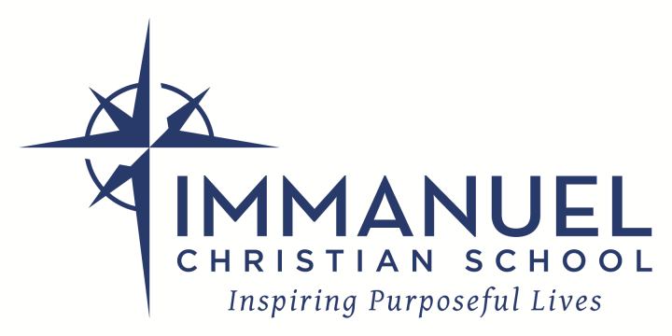

ESSENTIALS OF THE FAITH
(based on the Statement of Faith of Immanuel Bible Church)

We are, first of all, a Christian school and a ministry of Immanuel Bible Church (IBC) and as such establish the biblical basis from which we will teach a Christian world and life view. While we recognize that not all parents will agree with every item in this statement, it is necessary that the parents agree to support the premise that their child will be taught from the perspective provided in our statement of belief.

Our faculty is sensitive to areas of difference among Christians who love the Lord and seek to obey the dictates of Holy Scripture. We focus on the areas of agreement, not on issues which divide. It would be unacceptable for students or parents to seek to propagate doctrines that divide or are not in agreement with our statement of belief.

These are essentials of the faith as described in the full Statement of Faith of IBC. As such we believe:

1. the Bible is the verbally inspired Word of God and is the infallible rule for Christian faith, doctrine, and practice.
2. there is one true and living God, and that He has revealed Himself to men in three personal distinctions of deity: Father, Son, and Holy Spirit.
3. there exists a real personality who is the author of sin and god of this age, called Satan.
4. God created the heavens and earth and all life by direct act, and not by undirected evolutionary process.
5. each person is born with a fallen nature and as a result becomes a willful sinner.
6. the only salvation from sin is through redemption by personal faith in Jesus Christ.
7. salvation is by grace alone, and not by works, and that the saved are eternally secure in Christ.
8. the Church is a New Testament institution and is Christ's "Body" for service in this world and His Bride in eternity.
9. the two ordinances of the church are baptism and the Lord's supper.
10. there is an essential and everlasting difference between people who are saved and those who are lost.
11. Christ will, prior to the tribulation, catch away His church and return to rule during the millennium.
12. all persons will be resurrected to eternal reward or eternal punishment.
13. the Holy Spirit indwells the believer at the moment of salvation, baptizing the new believer into the Body of Christ and that baptism in the Holy Spirit occurs at that time.

ADMISSIONS POLICY

Immanuel Christian School partners with families to provide Christian education. We believe those who will benefit most from our program know the Lord as personal Savior and desire that their children be educated with a biblical worldview. It is our experience that families who do not share a biblical worldview will be uncomfortable with the expectations we have and the philosophy we practice. We do not discriminate on the basis of race, color, national or ethnic background. We do, however, attempt to be discerning in the area of Christian belief and practice. Rather than focusing on denominational affiliation, we define a Christian as a person who by faith has received Jesus Christ as personal Savior and rightful Lord of his or her life. Eph. 2:8, 9; Rom. 10:9, 10.

Information relating to special circumstances which may affect a student’s educational experience (such as behavior, learning difficulties or emotional issues) should be made known during the application process. We carefully and prayerfully evaluate how effectively we can meet the needs of each individual case. We must keep in view our

ministry to all of the students in a given class. Regrettably, we do not have the resources needed for many learning disabled or physically disabled students.

PARENT AGREEMENT

I agree that Immanuel Christian School should maintain its objective of thoroughly Christian education and should show evidence of that in policies for academic work, student behavior, and all relationships with students, employees, school families, churches, and the community.

I will cooperate with Immanuel Christian School (ICS) in the following ways:

- I will support school policies and rules and encourage my children to do so also by attitude, word, and deed. I will support the faculty and administration in disciplinary measures that they consider appropriate and in keeping with school policy.
- I understand the biblical role of Immanuel Christian School is to partner with families to encourage students to be imitators of Christ. This necessarily involves the school’s understanding and belief regarding Biblical morality and standards of conduct. I understand that the school reserves the right, within its sole discretion, to refuse admission to an applicant or to discontinue enrollment of a student if the atmosphere or conduct within a particular home or the activities of the student are counter to, or are in opposition to, the biblical lifestyle the school teaches. This includes, but is not limited to participating in, supporting, or condoning sexual immorality, homosexual activity or bi-sexual activity, promoting such practices, or being unable to support the moral principles of the school. (Lev. 20:13 and Romans 1:27.)
- I will promptly pay tuition and fees according to ICS financial policies listed in the Tuition and Fee Schedule understanding that failure to do so can result in dismissal.
- I understand that there are risks/dangers involved with participation in school activities both on and off campus and their associated activities (such as transportation). I accept those ordinary and reasonable risks associated with my child’s participation in school travel and activities.
- I authorize ICS, or anyone authorized by ICS, to use and reproduce any and all videos and photographs which ICS takes of my children or any family members (video masters, dubs, electronic images, and proofs) for school literature, advertisements and promotional purposes, without further compensation. All copies and masters, in printed or electronic form, together with the release dubs and proofs shall constitute ICS’s property, solely and completely.
- I understand that my contact information will be shared with the school community and I will give timely notice of any exceptions to sharing my information.
- I agree to support the school’s policy for resolving conflicts with others at ICS (students, teachers, administration, school board, parents, etc.) in accordance with biblical principles (Matthew 18:15-17; 1 Corinthians 6:1-8) and the procedures described in the Parent Student Handbook (available online) regarding Problem Solving, Resolution, and Mediation.
- I will regularly pray for the needs of the school, my child's teachers, the school administration and school board.
- I will fulfill my Parent Service Hours responsibility each semester consistent with school policy.

I understand that the application process includes the following:

- Submission of signed application forms including Statement of Faith, Parent Agreement and Admissions Policy.
- Submission of the non-refundable application fee prior to testing.
- Submission of teacher and administrator reference forms, academic records (when available) and health records.
- Submission of copies of all special evaluations including psychological, psychometric, learning disabilities, attention deficit, and hyperactivity, where applicable.
- Testing by ICS (Readiness testing for kindergarten and 1st and 2nd grade, and standardized achievement testing for grades 3 to 8) when necessary. A fee is required. See Tuition and Fee Schedule for details.
- Participation in an admission interview in person or by phone.
- A decision from ICS in writing. (Class assignment is an administrative decision based on the overall needs of the classroom. and may not necessarily be given at the time of admission.)

Please contact us with any questions at 703-941-1220 or admissions@icsva.org.

